|  |  |
| --- | --- |
|  | **FPT ACADEMY INTERNATIONAL**  **FPT – APTECH COMPUTER EDUCATION** |

**Centre Name: ACE-THUDUC-1-FPT.**

**Address: 391A, Nam Ky Khoi Nghia, District 3, Ho Chi Minh City, Viet Nam.**

GRACIOUS GARMENTS

|  |  |  |
| --- | --- | --- |
| **Supervisor.** | Mr. Nguyen Phat Tai | |
| **Batch.** | T3.2307.E1 | |
| **Group.** | Group 5 | |
| **Serial No.** | **Enrollment Number** | **Student Name** |
| 1. | **Student1491740** | **Le Hoang Long** |
| 2. | **Student1491726** | **Du Han Huy** |
| 3. | **Student1491746** | **Doan Duc Do** |

Nov-14-2023

**This is to certify that**

**Mr.:**

Le Hoang Long

Du Han Huy

Doan Duc Do

**has successfully designed & developed**

eProject: Gracious Garments website

**Submitted by: Du Han Huy**

**Date of issue: 14-NOV-2023**

**Authorized Signature: Huy**

**TABLE OF CONTENTS**

[ACKNOWLEDGEMENT 3](#_Toc84020490)

[SYNOPSIS 3](#_Toc84020491)

[PROBLEM DEFINITION 3](#_Toc84020492)

[CUSTOMER'S REQUIREMENTS SPECIFICATIONS (CRS) 3](#_Toc84020493)

[Business/Project Objective: 3](#_Toc84020494)

[Hardware/ Software Requirements: 4](#_Toc84020495)

[SCOPE OF THE WORK (IN BRIEF) 5](#_Toc84020496)

[Architecture and design of the system 6](#_Toc84020497)

[Diagram of the website 7](#_Toc84020498)

[TASK SHEET REVIEW 1 8](#_Toc84020499)

[SITE MAP 9](#_Toc84020500)

[MOCK OF THE WEBSITE 1](#_Toc84020501)0

[**1.** **HOMEPAGE** 1](#_Toc84020502)0

[**2.** **PRODUCTS** 1](#_Toc84020503)1

[**3.** **CATEGORIZED** 1](#_Toc84020504)2

[**4.** **COMPARE** 1](#_Toc84020505)3

[**5.** **CONTACT US** 1](#_Toc84020509)4

[**6.** **ABOUT US** 1](#_Toc84020512)5

[TASK SHEET REVIEW 2 1](#_Toc84020514)6

# ACKNOWLEDGEMENT

On behalf of all members of Team 5, I would like to thank all of you for your hard work and support to successfully complete this eProject. Especially Mr. Nguyen Phat Tai, our teacher, has helped us a lot since the day we started studying at FPT Aptech. With this eProject, the Teacher guided us very enthusiastically and heavily. Thanks to his guidance, we were able to complete this project. Additionally, I would like to thank all team 5 members, each team member worked continuously for 4 weeks to complete this project. Last but not least, we would like to thank our family for always supporting and creating the best conditions for us to focus on the project and believe in the dreams we pursue.

# SYNOPSIS

GRACIOUS GARMENTS is selling various types of GARMENTS for both MEN and WOMEN. The company advertises by distributing the pamphlets, advertising on television and so on. Due to rapid development in internet field, the company decides to launch a website where people will get all the information about the various products available with them easily.

# PROBLEM DEFINITION

The Web site is to be created based on the following requirements.

1. The Home Page should be created with proper sections, graphics and with a suitable logo.
2. Home Page should contain details of different Garments with suitable images.
3. The site should display a menu which will contain the options for brief introduction about the various garments available, location of the shop and any other information if required.
4. The information should be categorized according to the brand names of the products like if a User wants to see only “Van Heusen” products or any other companies products then he/she can click on a Link/button/menu etc and can see only that Brand products.
5. When a user selects any particular brand, a list of products for that brand will be displayed
6. A brief summary of features of individual products should be displayed on the Web Page along with the product but detailed Features should be stored in Individual Word documents which can be downloaded or viewed by the User who wishes to see the same.
7. The user should also be able to compare the various products of different as well as similar brands.
8. There should be a “Contact Us” page which will have the Address of the Company which is as follows and the mail address which when clicked will invoke the local mail client from where they can send an email.

# CUSTOMER'S REQUIREMENTS SPECIFICATIONS (CRS)

**Client: Gracious Garments**

### Business/Project Objective:

The Objective of this program is to give a sample project to work on real life projects. These applications help you build a larger more robust application.

The objective is not to teach you JavaScript/Dreamweaver but to provide you with a real life scenario and help you create basic applications using the tools.

You can revise the chapters before you start with the project.

This project is meant for students who have completed the module of Dreamweaver***.*** These programs should be done in the Lab sessions with assistance of the faculty if required.

It is very essential that a student has a clear understanding of the subject. Students should go through the project and solve the assignments as per requirements given.

Kindly get back to eProjects in case of any doubts regarding the application or its objectives.

**Input to the system:**

* + - * Browsing products based on brands, type of appliances..

**Output from the system:**

* A menu that will categorize all the functions of the site.
* Display the list of available albums category wisely.
* Perform the brief comparison by showing 2 products of the same type with their details.
* Site should be able to provide brief introduction/history about the company under About Us page.
* The location of the company is in Contact Us page.
* Besides the above requirements, the site should have look and feel as per the industry standards.

**Expected delivery date:** 14-NOV-2023.

**List of deliverables:**

* + - * Document Word.
      * User Guide.
      * Source code.

### Hardware/ Software Requirements:

**Hardware**

* + A minimum computer system that will help you access all the tools in the courses is a Pentium 166 or better.
  + 64 Megabytes of RAM or better.

**Software**

* + Notepad/HTML editor/CoffeeCup
  + Angular / Angular JS / React / BootStrap
  + Dreamweaver / Figma
  + MS IE / Chrome / FireFox / Netscape /MS Edge

# 

# 

# SCOPE OF THE WORK (IN BRIEF)

**The team has discussed and has agreed about the website layout as shown briefly below:**

1. **Homepage**: Showing brief introduction about the company and type of products that it is selling.
2. **Products**: Containing its products with their details and images categorized by type.
3. **Brands**: Containing its products with their details and images categorized by brands of the products.
4. **Compare**: Providing a clear view to the customer for brief comparison of 2 products among those on sale.
5. **Contact Us**: Showing the contact information of the company such as address, location map, mobile, fax, email.
6. **About Us**: Introducing the history, archivements and further information about the company.

# 

# Architecture and design of the system

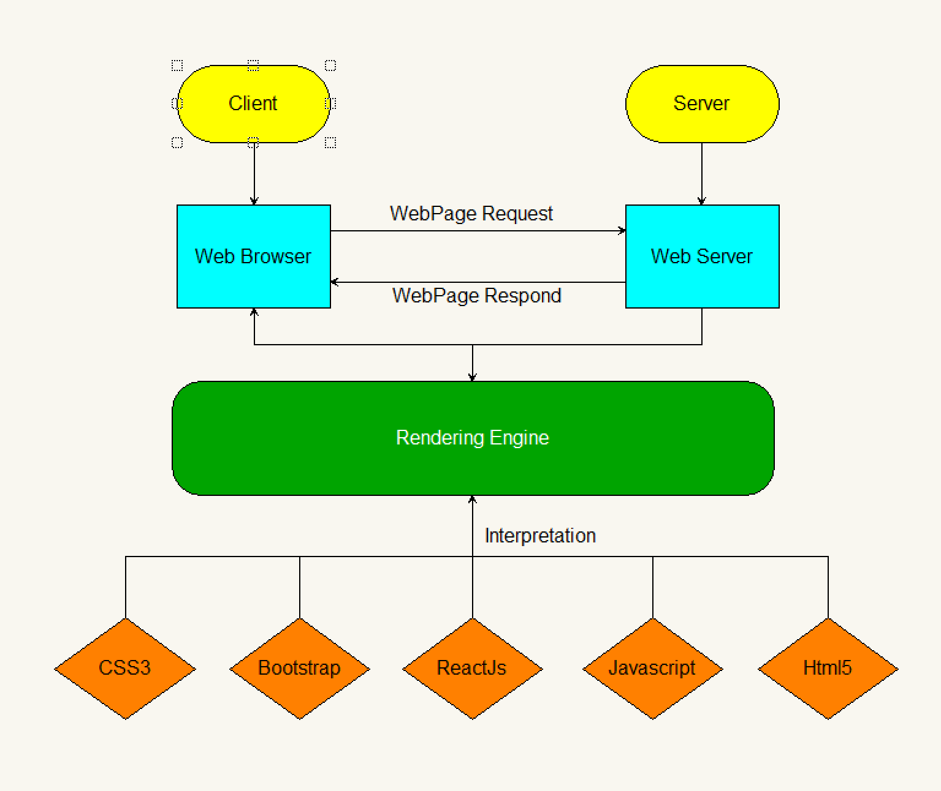

# Diagram of the website

**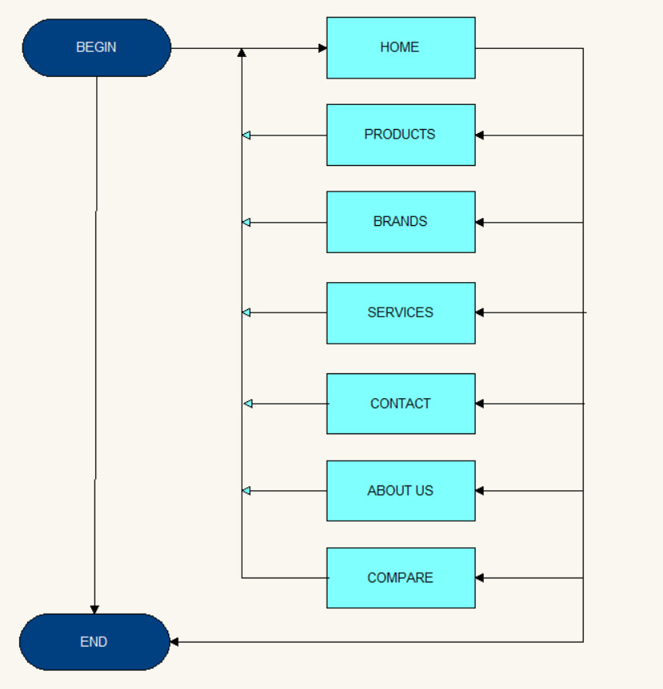**



TASK SHEET REVIEW 1

|  |  |  |  |  |  |  |  |
| --- | --- | --- | --- | --- | --- | --- | --- |
| **Project Ref. No.:**  **eP/Advertisement Portal Management**  **System/01** | | **Project Title:** | **Activity Plan Prepared By:** | **Date of Preparation of Activity Plan:** | | | |
| **Sr.**  **No.** | **Task** | **Actual**  **Start Date** | **Actual Days** | **Team**  **Mate Names** | **Status** |
| 1 | Problem Statement | Gracious Garments | Huy | 14-Oct-2023 | 1 | Huy,Long,  Do | Completed |
| 2 | Analysis of the requirements about the website | 14-Oct-2023 | 1 | Huy,Long,  Do | Completed |
| 3 | The scope of the work (in brief) | 14-Oct-2023 | 1 | Huy,Long,  Do | Completed |
| 4 | Architecture and design of the system | 14-Oct-2023 | 1 | Huy,Long,  Do | Completed |
| 5 | Diagram of the website | 14-Oct-2023 | 1 | Huy,Long,  Do | Completed |
| 6 | Task Sheet | 14-Oct-2023 | 1 | Huy,Long,  Do | Completed |

|  |  |
| --- | --- |
| **Date: 19/10/2023** | |
| Signature of Instructor:  **Mr. Nguyen Phat Tai** | Signature of Team Leader:    **Mr.Du Han Huy** |

# SITE MAP

# z4813288589398_836d66d4a31e8d925644b09aefada956

# MOCK OF THE WEBSITE

1. **HOMEPAGE**

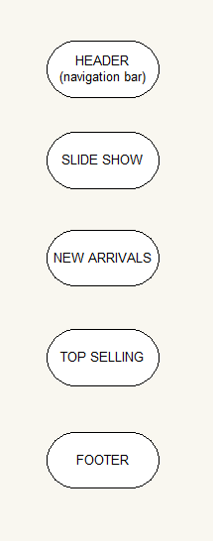

# PRODUCT

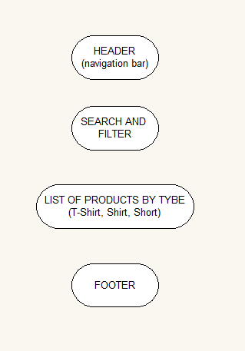

**3. CATEGORIZED**

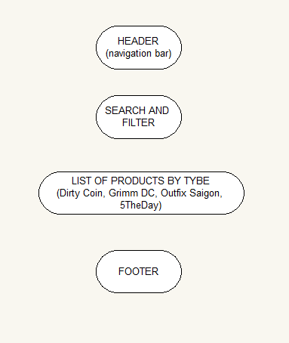

**4. COMPARE**

**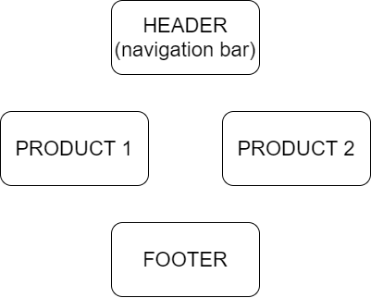**

**5. CONTACT US**

**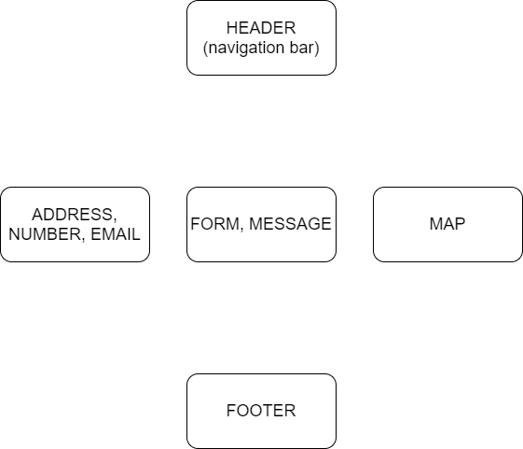**

**6. ABOUT US**

**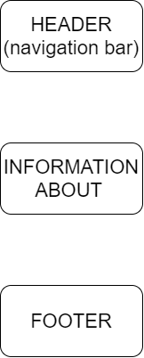**

# TASK SHEET REVIEW 2

|  |  |  |  |  |  |  |  |
| --- | --- | --- | --- | --- | --- | --- | --- |
| **Project Ref. No.:**  **eP/Advertisement**  **Portal Management System/01** | | **Project Title:** | **Activity Plan Prepared By:** | **Date of Preparation of Activity Plan:** | | | |
| **Sr.**  **No.** | **Task** | **Actual**  **Start Date** | **Actual Days** | **Team**  **Mate Names** | **Status** |
| 1 | Site map | Gracious Garments | Huy | 21-Oct-2023 | 1 | Huy,Long,  Do | Completed |
| 2 | Mock of the website | 21-Oct-2023 | 1 | Huy,Long,  Do | Completed |
| 3 | Task Sheet | 21-Oct-2023 | 1 | Huy,Long,  Do | Completed |

|  |  |
| --- | --- |
| **Date: 29/09/2023** | |
| Signature of Instructor:  **Mr. Nguyen Phat Tai** | Signature of Team Leader:  **Mr.Du Han Huy** |